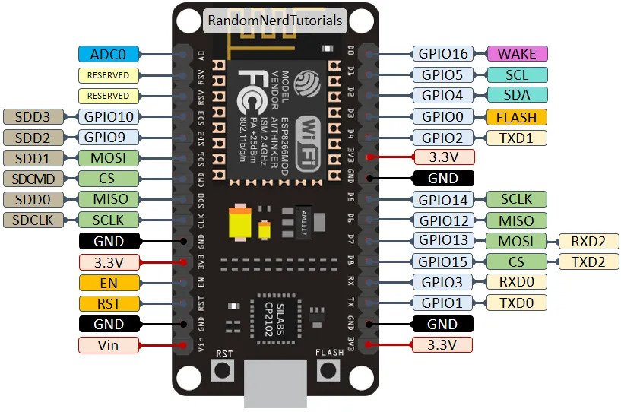

#define limit_switch1 14 // This is GPIO 14 on ESP - D5

#define limit_switch2 12 // This is GPIO 12 on ESP - D6

#define stop_switch 2 // This is GPIO 2 on ESP - D4

#define motor1EnPin 16 // This is GPIO 16 on ESP - D0

#define motor1StepPin 13 // This is GPIO 13 on ESP - D7

#define motor1DirPin 15 // This is GPIO 15 on ESP - D8

#define lineMotorEN 2 // This is GPIO 2 on ESP - D4

#define lineMotorIN1 5 // This is GPIO 5 on ESP - D1

#define lineMotorIN2 16 // This is GPIO 16 on ESP - D0